1. Write a python program using while loop to print the following  
   patterns. If required, use ‘break’, ‘continue’, ‘if’, ‘else’ statements
2. Pattern 1

CODE:

i = 1

while i <= 7:

    j = 1

    print ("\n")

    while j <= i:

        if i%2 == 0:

            print ("#", end="")

        else:

            print("\*", end="")

        j = j+1

    i = i+1

OUTPUT:

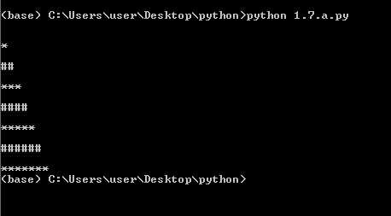

1. Pattern 2

CODE:

i=1

while i<=19:

    if i%2 == 0:

        pass

    else:

        print (i)

    i= i+1

OUTPUT:

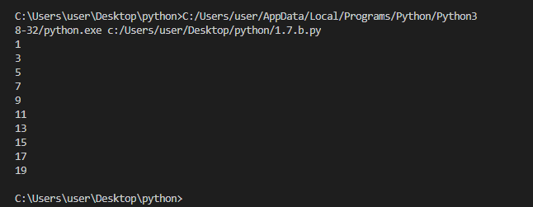

1. Pattern 3

CODE:

i = 1

while i<=7:

    j=1

    print("\n")

    while j <= i:

        print (i, end="")

        j = j+1

    i = i+1

OUTPUT:

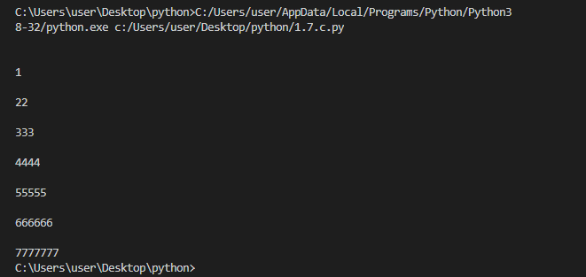

1. Pattern 4

CODE:

i = 1

while i <= 10:

    j = 1

    print ("\n")

    while j <= i:

        if i%2 == 0:

            print (i, end="")

        else:

            pass

        j=j+1

    i=i+1

OUTPUT:

